COMPILER DESIGN LAB -01

19CS02006 – KOUSHIK KUMAR

* Run in ubuntu terminal

(

before run following commands:

sudo apt install graphviz

sudo apt install xdg-utils

)

* Give valid string input
* OUTPUT FORMAT : GRAPH of NFA with start and end states.

here are some Examples :

* Expression : a|b\*c

expression : abcd

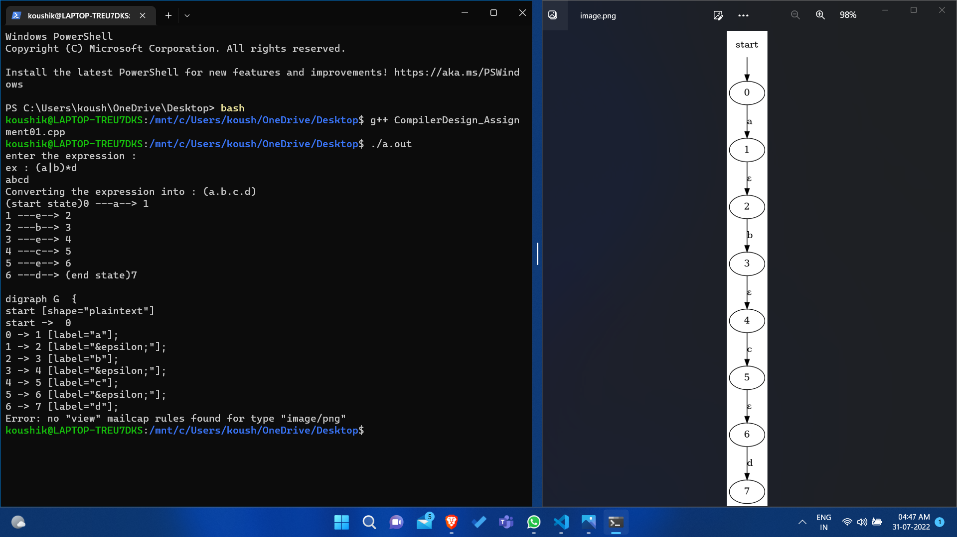

Expression :a|bc|d

